What are the rules of social distancing?
Staying home will stem the coronavirus outbreak, but what if you’re healthy — and bored? Is it ethical to go for a run in a crowded park, go to the store, or order delivery?

Many people in recent weeks have begun working remotely, if they haven’t been furloughed or laid off; schools have canceled classes for weeks; and restaurants, retail stores, gyms, and other gathering places in dozens of countries have shuttered.
These closures are all attempts to force social distancing, a crucially important public health intervention that can help stop transmission of the coronavirus. With Covid-19, “many people in the world will at some point, either this year or next, get exposed to this virus,” the Centers for Disease Control and Prevention’s immunization czar announced this month. Social distancing, health authorities argue, can dramatically slow the rate at which the infection spreads, helping to ease the burden on the health care system. Best practices require maintaining at least a six-foot distance between yourself and others.
The closures nationally are largely preventive — in some places, no one from work or school may have even been sick — though increasingly, these decisions are being made in response to the rapidly ballooning number of cases of Covid-19; the risk that contact with large groups of people will exacerbate transmission of the virus; and the growing understanding that the disease can be transmitted by those who are asymptomatic or appear to be relatively healthy. (At least one study estimated that about 25 percent of coronavirus transmissions may have occurred in pre-symptomatic stages — meaning it can be spread by people who don’t yet know they have it.)
What do you — as a responsible, socially conscious human being — owe to your fellow men and women, particularly those who are sick, immunocompromised, and older? Are you breaking the social contract by going to the grocery store?
Or, by not going, are you overreacting and hurting the economy?
Vox magazine spoke with six experts in public health, medicine, psychology, and bioethics for answers.

I feel healthy. Why shouldn’t I get out a little bit to make this time pass easier?
Vox’s Kelsey Piper makes a strong argument for choosing to stay home as much as possible, inconvenient as it may seem, to help your fellow human. “If you are young and healthy, you ought to take precautions because doing so can end up saving someone’s life,” she writes.
Leah Lagos, a New York City-based psychologist and author of the upcoming Heart, Breath, Mind: Train Your Heart to Conquer Stress and Achieve Success, agrees. “Now is the time to do something for your fellow community members,” she says. Staying home as much as possible, even if you believe you aren’t infected, is the type of altruistic decision that, when performed en masse, has the potential to slow the infection rate, Lagos added. It’s a term known as “flattening the curve,” and the way it works can be seen below:
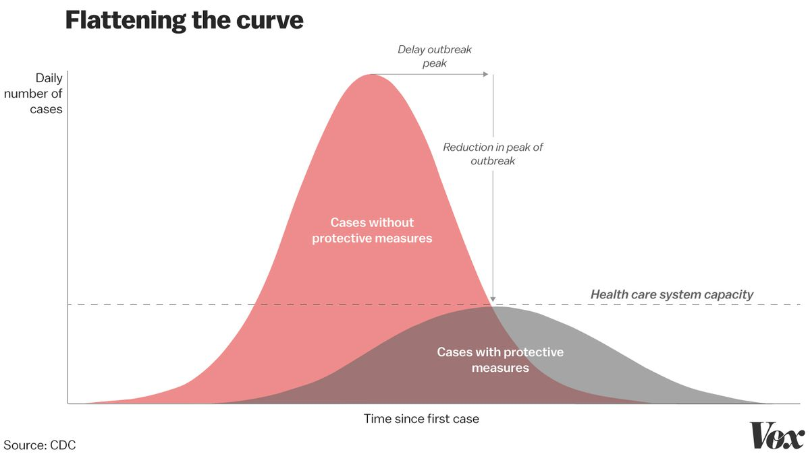Christina Animashaun/Vox
Considering — and prioritizing — the welfare of strangers is difficult, Lagos acknowledges, but it helps to think of them instead as someone else’s parent, grandparent, or child. “It can be an interesting experiment in compassion for people we don’t know.”
“A lot of us might be relatively healthy and think we might be able to withstand the rigors of an infection,” adds Jonathan Kimmelman, director of the Biomedical Ethics Unit at McGill University in Montreal, “but there’s the concern about spreading it to vulnerable individuals, as well as the pressure this outbreak will place on our health care system.”
Kimmelman invokes the idea of “social solidarity,” saying that “we have an ethical obligation to curtail activities, practice social distancing, and substitute activities with safer alternatives,” like teleconferencing instead of in-person work meetings “

If I have to go out, how can I do it in the safest way possible — to protect myself as well as others?
Kate Vergara, a public health and infectious disease specialist based in Chicago and New York City, has spent time fighting polio in Ethiopia and helping Ebola survivors in Sierra Leone (without contracting either disease). In order to even begin to approach the ethics of social distancing, she says, we must have a firm grip on how the virus is spreading.
“Covid-19 is not airborne,” she says. “It is transmitted through droplets — being coughed on or touching something that someone coughed on, for example, and then touching your face and allowing that pathogen to get into your system through your eyes, nose, or mouth.”
It’s important to practice good hygiene, like hand-washing — which protects not only you but also others. When considering the ethics of spending time out and about, Vergara suggests reframing your view of hand-washing in the following way: “Wash your hands before you go out to protect others, and wash them again after the activity to protect yourself.” That goes for visiting the ATM, the grocery store, and the like.
The CDC recommends several basic measures to help prevent the spread of Covid-19:
- Wash your hands often for at least 20 seconds.
- Cover your cough or sneeze with a tissue, then throw the tissue in the trash.
- Clean and disinfect frequently touched objects.
- Stay home as much as possible, and do not go out if you are sick.
- Wear a cloth face covering in public.
- Contact a health worker if you have symptoms.

Should I feel guilty for wanting to go for a run or to a store?
Between the relentless news alerts, social media memes, and gossipy texts, it’s easy to feel overwhelmed, anxious, and scared. We need self-care more than ever, says LaMar Hasbrouck, a public health physician and former CDC medical epidemiologist. “It’s important during these times to hold fast to any sense of normalcy that you can.”
But try to find prudent ways to do so. Hasbrouck now picks off-peak hours to exercise to minimize contact with others; other options include walking, jogging, or biking outdoors, while making sure to maintain distance from others. The more ventilated an area, the lower the risk of transmission, plus, “If you cough, nobody is around, and the droplets just fall and hit the ground,” he says. Better yet: breaking a sweat at home with help from an app or online video.
Grocery shopping will need to happen, but instead of going at noon on a Saturday when the place is sure to be packed, try going really early on a weekday morning. If it’s still possible, order online. Wash your hands after handling any deliveries, just to be safe.

Should I cancel play dates? What are the rules for my kids?
In Ireland, public health officials are encouraging a “no parties, no playdates, no playground” policy, per the Irish Times. Muireann Ní Chrónín, a consultant respiratory pediatrician at Cork University Hospital, told the paper: “In most epidemics, young children are the transmitters.” With Covid-19, older people are most at risk, but children can spread the disease, and at least a small risk of severe illness is present for all age groups.
In the US, school closures are smart, Vergara says. “It’s a responsible practice for schools to shut down. That’s several hundred kids interacting in close quarters, and kids aren’t known for washing their hands very well.” But that leaves millions of working parents frantic about career responsibilities, and unsure of whether it’s appropriate to schedule play dates or try to split child care duties with friends.
Lagos worries that play dates during school closures are essentially “quasi-quarantines, defeating the purpose of social distancing.” Kimmelman concurs, and though he says no one knows the exact right answer, “we don’t know how things are going to unfold, and from my standpoint, the risks of underreaction are so much more catastrophic than the risks of overreaction.”
“consider other ways in which you can make things easier for one another — whether it’s sharing creative activities to keep the kids entertained or taking turns grocery shopping. … Be open to new ways of doing things.”

When should I completely self-quarantine?
The CDC has issued recommendations for travelers arriving from dozens of countries with widespread cases to stay home for 14 days. The White House has also encouraged anyone who has been in New York in recent days and left to self-quarantine for 14 days because of the rapidly growing number of cases there.
But if you have a fever or receive new information — that someone you know was exposed — you’re also going to want to “radically change your assessment,” Hasbrouck says. That likely means self-quarantining, because that’s “the ethical decision and you don’t want to expose others. It’s a constant risk assessment, and it’s more of an art than a science. It’s about protecting yourself but also being socially responsible.”

How far should we take social distancing advice?
“Look at the trajectory of what’s happening in Italy. We’re 11 days behind Italy,” where a national lockdown that began March 10 has curtailed all travel and shuttered nearly all shops, schools, museums, movie theaters, and bars, says Madad. Some states and cities are observing less stringent measures than others, and a federal mandatory quarantine isn’t likely, but we can undertake distancing measures ourselves. “One of the things we’ve learned from the H1N1 pandemic is that if you educate people, they will listen. You have to give them the facts, and speak with one voice.”

