**Batna 2 University**

**Faculty of Letters and foreign Languages**

**Department of English language and literature**

**Instructor: Mr.Ais First year grammar courses Group 08 & 09**

**Syllabus :**

**Parts of speech forms , types, and functions**

**1.Nouns**

**2.Pronouns**

**3.Verbs**

**4.Adjectives**

**5.Adverbs**

**6.Conjunctions**

**7.Prepositions**

**8.Interjections**

**1. Nouns**

**Concrete, Abstract, and Collective**

A **noun** is a word that names a person, place, thing, or idea. A **singular noun** names one person, place, thing, or idea, and a **plural noun** names more than one.

**SINGULAR PLURAL**

Person: friend friends

Place: field fields

Thing: melody melodies

Idea: freedom freedoms

A **collective noun** names a group. A collective noun is singular when it refers to the group as a whole. A collective noun is plural when it refers to the individual members of a group.

The **committee** is studying the issue. (singular)

The **committee** have gone to lunch. (plural)

A **concrete noun** names an object that occupies space or can be recognized by any of the senses.

Grass apple stars actor

An **abstract noun** names an idea, a quality, or a characteristic.

Beauty splendor poverty anger success

**Proper and Common Nouns:**

A **proper noun** is the name of a specific person, place, or thing. Proper nouns are capitalized.

A **common noun** refers to persons, places, or things in general.

**PROPER NOUNS** **COMMON NOUNS**

Person: George Washington president

Place: Sahara desert

Thing: Iguanodon dinosaur

Idea: Renaissance thought





**2. Pronouns**

**Personal and Possessive; Reflexive and Intensive**

A **pronoun** is a word that takes the place of a noun, a group of words acting as a noun, or another pronoun.

A **personal pronoun** refers to a specific person or thing by indicating the person speaking (the first person), the person being addressed (the second person), or any other person or thing being discussed (the third person).

SINGULAR PLURAL

First person I, me we, us

Second person you you

Third person he, him, she, her, it they, them

A **possessive pronoun** shows possession or control. It takes the place of a possessive noun.

SINGULAR PLURAL

First person my, mine our, ours

Second person your, yours your, yours

Third person his, her, hers, its their, theirs

A **reflexive pronoun** refers to a noun or another pronoun and indicates that the same person or thing is involved. An **intensive pronoun** adds emphasis to a noun or another pronoun.

He surprised **himself** by breaking the home-run record. (reflexive)

Leo **himself** prepared the main course. (intensive)

SINGULAR PLURAL

First person myself ourselves

Second person yourself yourselves

Third person himself, herself, itself themselves

**Interrogative and Relative; Demonstrative and Indefinite**

An **interrogative pronoun** is used to form questions. Interrogative pronouns are *who, whom, whose, what,* and *which*. Other forms of the interrogative pronouns are *whoever, whomever, whosoever, whatever,* and *whichever*.

**Example**

**Who** is planning to attend the silent auction?

**Whatever** are the Wilsons going to do with the leftover potato salad?

A **relative pronoun** is used to begin a special subject-verb word group called a subordinate clause.

The tour guide says this is the invention **that** changed history.

**RELATIVE PRONOUNS**

who whom what which that

whoever whomever whatever whichever whose

A **demonstrative pronoun** points out specific persons, places, things, or ideas.

**This** was signed by the entire class.

**SINGULAR PLURAL**

This these

That those

An **indefinite pronoun** refers to persons, places, or things in a more general way than a noun does.

**Someone** decorated the dining room for Corinne’s birthday.

INDEFINITE PRONOUNS

All both everything none some

Another each few nothing somebody

any either many one someone

anybody enough most other something

anyone everybody neither others

anything everyone nobody several

Practice:

**Practice:**

**a.Identifying Reflexive Pronouns**

Directions: Circle the reflexive pronoun in each sentence below.

1. Make sure to remind yourself of the things you need to do.

2. She thought to herself while she was in the library.

3. I saw myself in the mirror.

4. We blamed ourselves for the mistake.

5. Can you help yourselves?

6. They cannot look after themselves.

**b.Identifying Intensive Pronouns**

Directions: Circle the intensive pronoun in each sentence below.

1. Did you yourself make the dinner?

2. I myself like to take walks after breakfast.

3. She herself did a great job on setting up the party.

4. Leave it alone! I will do it myself.

5. Did you discover that yourself?

6. I myself feel like I did a great job.

**c.Reflexive or Intensive Pronoun**

Directions: Write an “R” on the line if the pronoun in the sentence is **reflexive**. Write an **“I”** on the line if the pronoun is **intensive**.

**______1.** We ourselves made sure to be on time.

**______2.** I bought a gift for myself.

**______3.** Why do you blame yourself for everything?

**______4.** You yourself need to be more careful.

**______5.** They themselves are ready for the game.

**d. In the sentences below, identify each underlined pronoun by writing above the pronoun D for demonstrative, I for interrogative, or R for relative.**

I R

Example 1. What did Maria learn that helped her to solve the equation?

1. Of those colleagues, whom will you take to the session that begins at noon?

2. This is an outline that explains how to study properly.

3. Of the cat’s newborn kittens, these are the two that I will adopt.

4. Aunt Phyllis saw my book and asked, “Whose is this?”

5. Inez is among those who are trying out for roles in the spring musical.

6. Which of those does Angelo think is the better design for the new student center?

7. These are the problems for both teams: the weather, which doesn’t seem to be improving, and

transportation to the stadium.

8. Jackson said, “Many people have told me that. Why should I not believe the story that I

have heard?”

9. He read aloud Browning’s sonnet, which was the most touching poem that I had ever heard.

10**.** Lomasi told Henry, whom she trusted, something that she wanted him to keep secret.

**e. In each of the sentences below, underline the type of pronoun given in parentheses at the end of the sentence.**

**Example 1.** Who is coordinating the planning for this year’s event? *(interrogative)*

**11.** Those involved with music are preparing for the annual music festival. *(demonstrative)*

**12.** The crowd, which was very large last year, is expected to double. *(relative)*

**13.** The bands that will draw the largest crowds should begin at noon. *(relative)*

**14.** Several of these, whose music many have heard, have won competitions. *(demonstrative)*

**15.** Who could ask them whether they will play rock or blues or both? *(interrogative)*

**3. Verbs**

**Main Verbs and Helping Verbs**

A ***verb*** expresses action or a state of being.

A***main verb*** and one or more ***helping verbs*** (also called ***auxiliary verbs***) make up a ***verb phrase.***

A***modal*** is a helping verb that is joined with a main verb to express an attitude such as

necessity or possibility.

**VERBS** A pair of robins **landed** in the tree and **began** to build a nest.

**VERB PHRASES** The concert **has been canceled,** but it **will** soon **be rescheduled.**

**MODALS** If you **must** go outside in this weather, you **should** wear a good hat.

**a)Action Verbs**

An ***action verb*** expresses either physical or mental activity.

**PHYSICAL ACTIVITY** run, draw, push

**MENTAL ACTIVITY** think, remember

**b)Linking Verbs**

A ***linking verb*** connects the subject to a word or word group that identifies or describes the subject. Such a word or word group is called a ***subject complement.***

look become be smell, taste, feel,

**EXAMPLES**

This meal **smells** delicious!

Who **is** the new class president?

That **must be** one of the oldest buildings in the city.

**c) Transitive and Intransitive Verbs**

A ***transitive verb*** has an ***object***—a word that tells who or what receives the action.

An ***intransitive verb*** does not have an object.

**TRANSITIVE** Becky **gave** her speech first. [The object *speech* receives the action of the verb *gave.*]

Frank **has thrown** more touchdown passes than anyone else in the division. [The object *passes* receives the action of the verb *has thrown.*]

**INTRANSITIVE** Rain **has been falling** for the last three hours.

The detective **is** very perceptive.

**Practice**

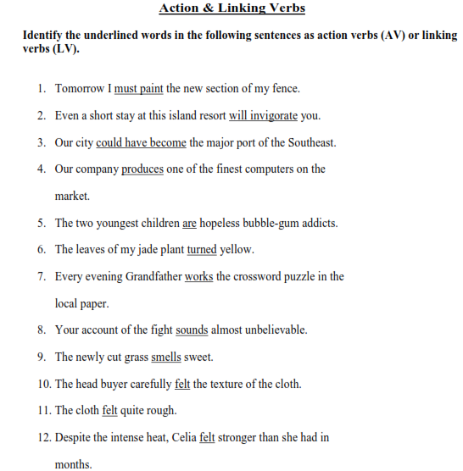

**Transitive &Intransitive Verbs**

**In the following exercise underline the verbs and tell whether they are transitive or intransitive. Circle the direct objects.**

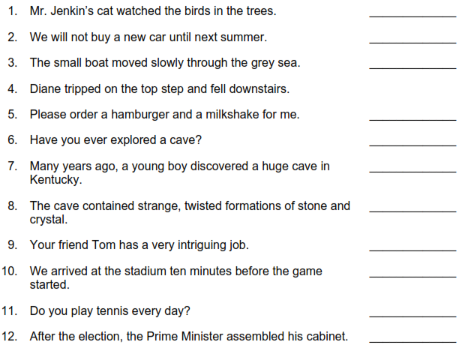

**4. Adjectives**

An **adjective** is a word that modifies a noun or a pronoun by limiting its meaning.

**dark** clouds **wet** snow **clear** lake **magnificent** lightning

Adjectives include the articles *a*, *an*, and *the*. *A* and *an* are **indefinite** articles; *the* is a **definite** article.

**A** dove glided over **the** orange trees.

Because they modify nouns, possessive nouns and pronouns are considered adjectives as well.

Place **your** jacket next to **Ryan’s** jacket.

A **proper adjective** is formed from a proper noun and begins with a capital letter. Proper adjectives are often created by using the following suffixes: *-an*, *-ian*, *-n*, *-ese*, and *-ish*.

We ate **German** food and listened to **African** music at the international festival.

**Practice**

***a.In the sentences below, circle the nouns used as adjectives. Draw an arrow from each noun used as an adjective to the noun it modifies.***



1. Mr. Tanaka is an entertaining dinner guest.
2. The program committee decided to cancel the dance.
3. The student association became involved in the project.
4. Graduation day is exactly one week away.
5. It was a thrilling experience to ride the police helicopter.
6. This semester my most interesting course is world history.
7. The politicians are debating their party platform.

***b.Listing three adjectives***

1. 1. Name three complimentary adjectives that describe one of your friends:
2. ____________________ ____________________ ____________________
3. 2. Name three adjectives that describe the beach on a summer’s day:
4. ____________________ ____________________ ____________________
5. 3. Name three adjectives that describe a book or magazine article that you recently read:
6. ____________________ ____________________ ____________________
7. 4. Name three adjectives that describe a typical spring day where you live:
8. ____________________ ____________________ ____________________
9. 5. Name three adjectives that describe your favorite song:
10. ____________________ ____________________ ____________________
11. 6. Name three adjectives that describe one of your most difficult experiences:
12. ____________________ ____________________ ____________________

**5. Adverbs**

An **adverb** is a word that modifies a verb, an adjective, or another adverb by making its meaning more specific. Adverbs answer the questions *how? when? where?* and *to what* *degree?*

When modifying a verb, an adverb may appear in various positions in a sentence. When modifying an adjective or another adverb, an adverb appears directly before the modified word.

The boy had run **quickly** home. (*Quickly* modifies the verb phrase *had run.*)

Kate is **very** nervous about her performance. (*Very* modifies the adjective *nervous*.)

Dr. Delacorte removed the bandages **quite carefully**. (*Quite* modifies the adverb

*carefully; carefully* modifies the verb *removed*.)

The negatives *no, not,* and the contraction *-n’t* are adverbs. Other negative words, such as *nowhere, hardly,* and *never,* can function as adverbs of time, place, and degree.

I could**n’t** remember where I left my science book.

The rain **never** begins until softball practice starts.

**Practice**

**Exercise 1: Draw an arrow from each adverb to the word it modifies.**

The children were happily playing in the park for an hour.

**1.** We gleefully danced because of our victory.

**2.** My sister can type fast.

**3.** The maple tree in the yard is gradually losing its leaves.

**4.** The grandfather clock chimes merrily.

**5.** The big harvest moon shone brightly in the October sky.

**6.** Father loudly whistled for his dog.

**7.** The high school band marched proudly in the festival parade.

**8.** I thought the conductor was rather late in calling, “All aboard!”

**9.** The muddy creek flows very quickly.

**10.** The young artist watched the master closely.

**Exercise 2 Draw a line under each adverb. Write in the blank the type of word it modifies: *V***

**(verb), *adj.* (adjective) or *adv.* (adverb).**

**V** The balloon floated gently toward the sky.

**V 1.** The wind whistled sharply through the trees.

**V 2.** The crowd angrily protested the court’s decision.

**V,3.** He hardly had the ball, and then he dropped it.

**a 4.** I enrolled in a slightly unusual course.

**a5.** Diane carried the carton of eggs very carefully.

**V 6.** Teri and Samantha worked on their science project yesterday.

**a 7.** In spite of the setbacks, John succeeded quite well.

**V 8.** We cheerfully rode many miles in the restored train.

**V 9.** How will you maintain your grades?

**10.** She joined the club extremely early to qualify for the contest.

**6. Prepositions**

A **preposition** is a word that shows the relationship of a noun or pronoun to some other word in the sentence.

The book **on** the table was written **by** Dr. Kotlinski.

The story **of** Hercules fascinates me.

**COMMON PREPOSITIONS**

Aboard as but (=except ) in out toward

about at by inside outside under

above before concerning into over underneath

across behind despite like past until

after below down near pending unto

against beneath during of regarding up

along beside except off since upon

amid besides excepting on through with

among between for onto throughout within

around beyond from opposite to without

A **compound preposition** is a preposition that is made up of more than one word.

according to apart from because of in front of next to out of

ahead of aside from by means of in spite of on account of owing to

along with as to in addition to instead of on top of

Phrases that begin with a preposition usually end with a noun or pronoun called the

**object of the preposition**.

The man arrived **with the pizza**. Everything went **according to plan**.

**Practice**

**Exercise : underline each preposition in the following sentences**

Before this launch, the Soviet Union built a satellite named *Sputnik*.

**2.** It circled Earth in 1957.

**3.** *Sputnik* weighed only 184 pounds and fell to Earth within three months.

**4.** The Russians launched *Sputnik II* on November 3, 1957.

**5.** A dog was along for the ride.

**6.** The scientists wanted to see how long it would live in space.

**7.** It lived one hundred hours after takeoff.

**8.** The 1960 *Tiros I* demonstrated a satellite’s value in weather forecasting.

**9.** The year 1960 also saw the Soviet Discoverer capsules tested for passengers.

**10.** The Russians developed space capsules intended for human use, too.

**11.** The first man in space was Yuri A. Gagarin.

**12.** He made a single orbit around Earth.

**13.** According to records, the date was April 12, 1961.

**14.** Gagarin was two hundred miles above Earth.

**15.** The American project Mercury was initiated in 1958.

**7. Conjunctions**

A **conjunction** joins single words or groups of words.

**a.Coordinating conjunction**

A **coordinating conjunction** joins words or groups of words that are equal in grammatical importance. Coordinating conjunctions “ **FANBOYS**” include *and, but, or, nor, for,* and *yet.*

I wrote the letter **and** mailed it. It looked cloudy, **yet** we hoped for sunshine.

**b.Correlative conjunction**

**Correlative conjunctions** work in pairs to join words and groups of words of equal

importance. Correlative conjunctions include *both...and, just as...so, not only...but also,*

*either...or, neither...nor,* and *whether...or.*

**Either** we leave now, **or** we don’t leave at all.

**Both** Gina **and** Simone compete in gymnastics.

**c. Subordinating conjunction**

A **subordinating conjunction** joins a dependent idea or clause to a main clause.

**COMMON SUBORDINATING CONJUNCTIONS**

After as long as considering (that) than whenever

Although as soon as if though where

As as though in order that unless whereas

as far as because since until wherever

as if before so that when while

**Example**

The movie starts **after** the advertisements finish.

We finished early **so that** we could go home.

**Practice**

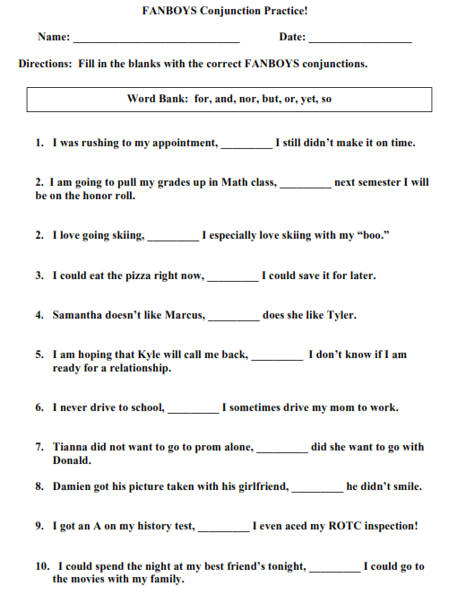

**Exercise 02 : Draw a line under each conjunctive adverb.**

Hey! Casey won the contest; therefore, he became famous.

**1.** The *Hesperus* sank; moreover, there were no survivors of the wreck.

**2.** Dennis failed to follow the recipe; consequently, his pancakes did not turn out well.

**3.** We did not have enough money for the bus ride; besides, we enjoyed the walk.

**4.** General Douglas MacArthur was a great leader in World War II; similarly, George Patton won

military glory in that conflict.

**5.** Those clouds are lovely; however, they signal coming bad weather.

**6.** Dominique loves this ring; moreover, she actually has enough money to buy it.

**7.** You have to sit through a poor movie; however, a poor book you can put down.

**8.** Diego has to give a speech today; consequently, he is very nervous.

**10.** Sheila loves math class; similarly, she appreciates learning about chemistry.

**11.** I’ve always wanted to fly; indeed, I’ve even dreamed about it.

**12.** It is raining; otherwise, we would be outside.

**16.** Larry passed his driving test; therefore, he wants to celebrate.

**17.** Denise is at swimming practice; likewise, Shawn is playing volleyball.

**19.** Those new clothes in the store window look great; nevertheless, they’re too expensive.

**20.** Let’s enter the dance contest, Teri; furthermore, let’s win it.

**21.** Bart slept until noon; then, he had to explain why he was late for his weekend job.

**22.** Guides led the visitors around the house; then, the party finally began.

**8. Interjections**

An **interjection** is a word or phrase that expresses emotion or exclamation. An interjection has no grammatical connection to other words and no grammatical function.

**Example**

**Oh**, is that so? **Hey**! Watch out or you’ll get hurt!

**Whoa!** Don’t try to carry so much at one time.

I thought that, **well,** you might like to see a movie this weekend.

**Practice**

**Underline interjections in the following sentences**

1.Ouch! I cut my finger on this stack of papers.

2.Aha! I caught you raiding the refrigerator.

**3.** Well, how do you think the story ended?

4.Wow! That is a blimp floating across the sky.

5.Well, if you insist, I’ll give him a call.

6.Oh! You cleaned your room; therefore, you can have the last piece of pumpkin pie.

7.No! Don’t put aluminum foil in the microwave oven.